Ranking Tree
Code:
import pandas as pd
import numpy as np
from sklearn.tree import DecisionTreeClassifier
from sklearn.datasets import load_breast_cancer
from sklearn.tree import plot_tree
from sklearn.model_selection import train_test_split
from sklearn.metrics import roc_curve

from scipy.sparse import data
data=load_breast_cancer()
X=data.data
y=data.target

X_train, X_test, y_train, y_test = train_test_split(X, y, test_size = 0.2, random_state = 101)

ranking_model = DecisionTreeClassifier(random_state=0, criterion='entropy', max_depth=3)
ranking_model.fit(X_train, y_train)

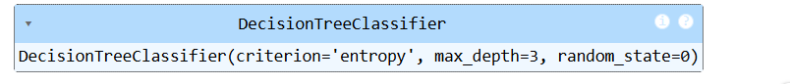
predicted_scores = ranking_model.predict_proba(X_test)[:, 1]

ranking_indices = np.argsort(predicted_scores)[::-1]
ranking_predicted_scores = predicted_scores[ranking_indices]
ranking_actual_labels = y_test[ranking_indices]

plt.figure(figsize=(10, 6))
plot_tree(ranking_model, feature_names=data.feature_names, class_names= data.target_names, filled=True, rounded=True)
plt.show()

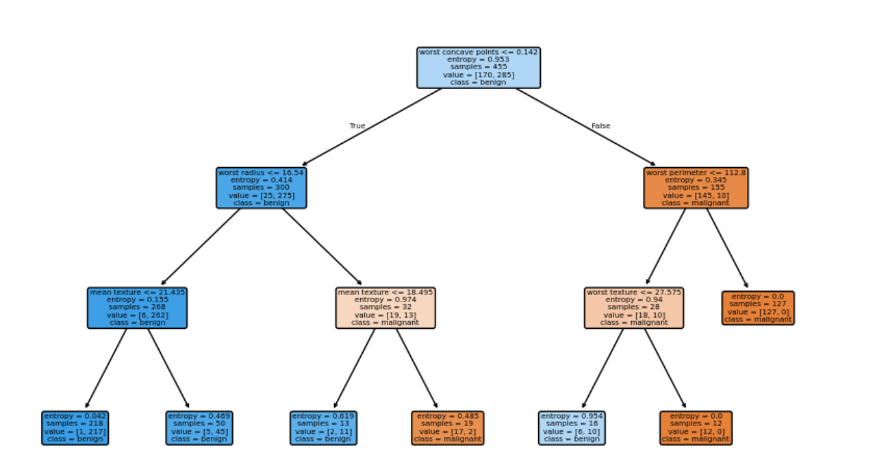

plt.figure(figsize=(15, 8))
plt.bar(range(len(ranking_predicted_scores)), ranking_predicted_scores, label='Predicted Scores',
color = ['red' if label ==1 else 'blue' for label in ranking_actual_labels])
plt.title('Ranking of Predicted Scores')
plt.xlabel('test instance rank')
plt.ylabel('Predicted Scores( probability of malignant)')
plt.legend(handles = [plt.Line2D([0], [0], color = 'red', lw=4, label = 'Malignant (Actual)'),
plt.Line2D([0], [0], color = 'blue', lw=4, label = 'Benign (Actual)')])
plt.grid(axis='y')
plt.show()

Output:
